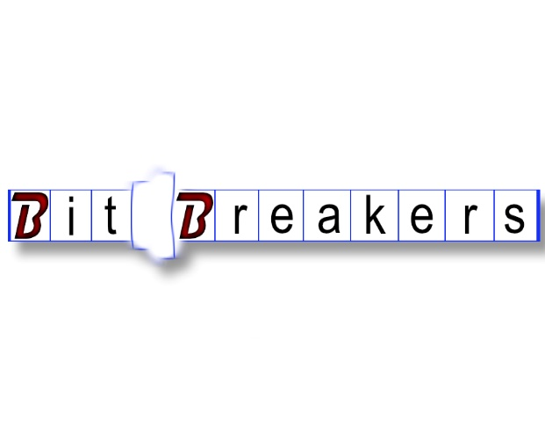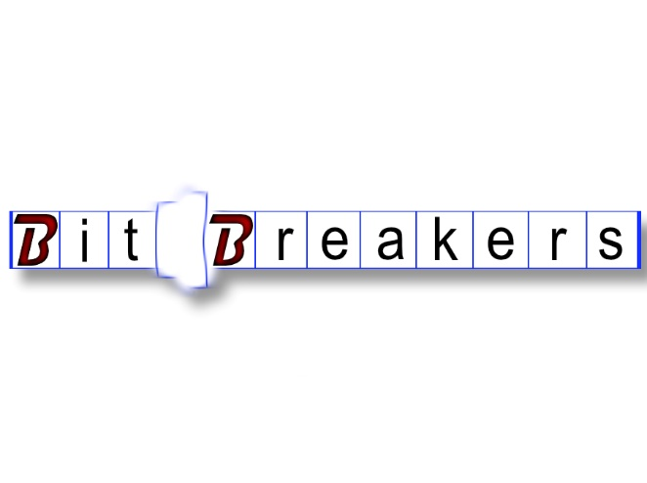

|  |  |
| --- | --- |
| Jon Gillespie  123 Main, Salem, Or 97303  555-555-5555 | jgillespie17@wou.edu  CEO Bit Breakers  github.com/jgillespie17 | Jon Gillespie  123 Main, Salem, Or 97303  555-555-5555 | jgillespie17@wou.edu  CEO Bit Breakers  github.com/jgillespie17 |
| Jon Gillespie  123 Main, Salem, Or 97303  555-555-5555 | jgillespie17@wou.edu  CEO Bit Breakers  github.com/jgillespie17 | Jon Gillespie  123 Main, Salem, Or 97303  555-555-5555 | jgillespie17@wou.edu  CEO Bit Breakers  github.com/jgillespie17 |
| Jon Gillespie  123 Main, Salem, Or 97303  555-555-5555 | jgillespie17@wou.edu  CEO Bit Breakers  github.com/jgillespie17 | Jon Gillespie  123 Main, Salem, Or 97303  555-555-5555 | jgillespie17@wou.edu  CEO Bit Breakers  github.com/jgillespie17 |
| Jon Gillespie  123 Main, Salem, Or 97303  555-555-5555 | jgillespie17@wou.edu  CEO Bit Breakers  github.com/jgillespie17 | Jon Gillespie  123 Main, Salem, Or 97303  555-555-5555 | jgillespie17@wou.edu  CEO Bit Breakers  github.com/jgillespie17 |
| Jon Gillespie  123 Main, Salem, Or 97303  555-555-5555 | jgillespie17@wou.edu  CEO Bit Breakers  github.com/jgillespie17 | Jon Gillespie  123 Main, Salem, Or 97303  555-555-5555 | jgillespie17@wou.edu  CEO Bit Breakers  github.com/jgillespie17 |